在看“4轴带视觉 - Zhmi版”这个例程 第一个界面的启动，停止，暂停，归零这四个功能。以及HMI界面的制作。和HMI寄存器的使用

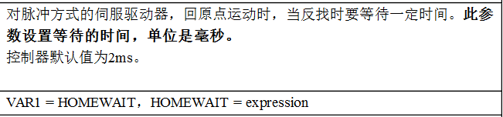

**手动操作**

手动和手动停止

PROC_STATUS

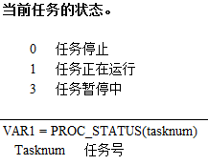

Vmove

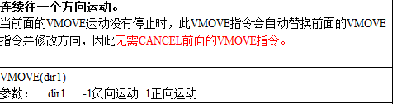

RAPIDSTOP

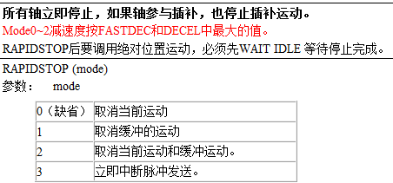

**错误信息**

move_op2

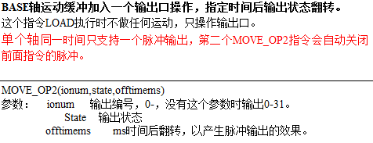

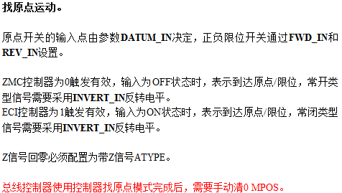

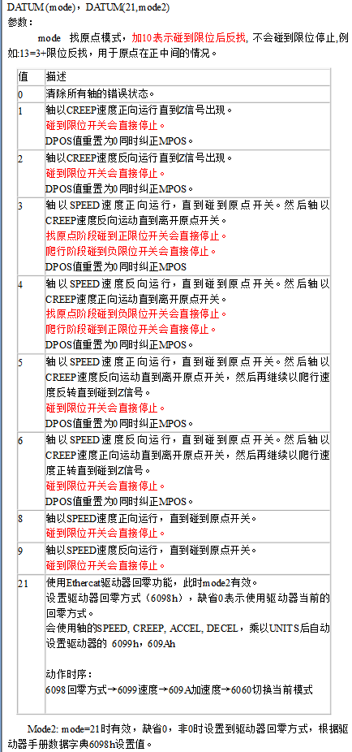

轴参数设置 保存

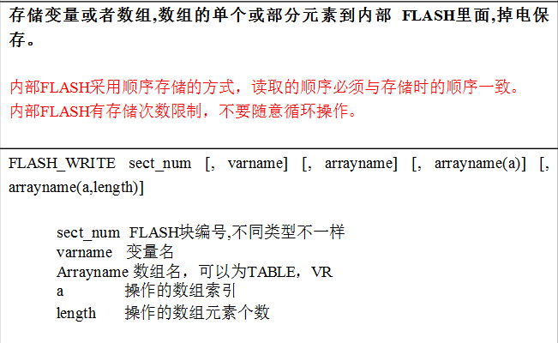

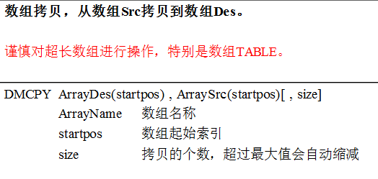

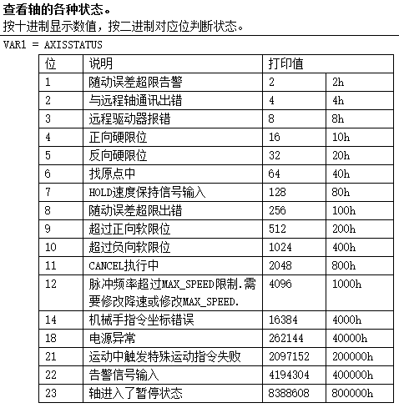

直线

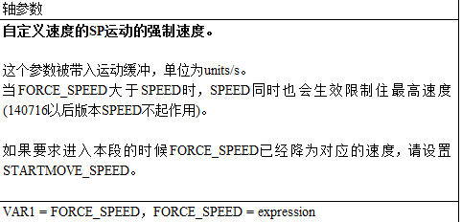

三点圆弧

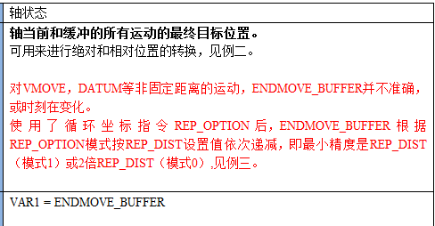

延时

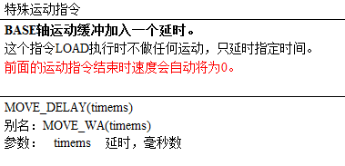

输出

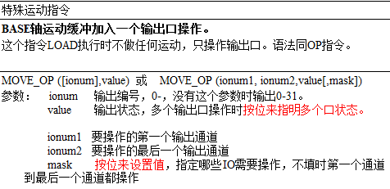

输出复位

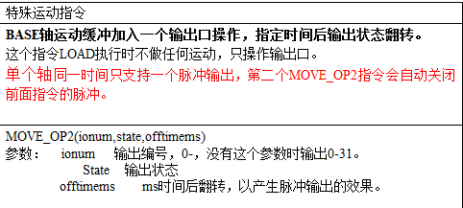

0起始速度 lspeed

1运行速度 speed

2加速度 accel

3减速度 decel

4S曲线 sramp

5复位速度 speed

6反找速度 creep

7示教速度

8回零方式 datum

9反找等待 HOMEWAIT

10每圈脉冲数

11螺距

12负向软限位 RS_LIMIT

13正向软限位 FS_LIMIT

14原点IN datum_in

15反转 INVERT_IN

16正限位IN fwd_in

17反转 INVERT_IN

18负限位IN rev_in

19反转 INVERT_IN

20报警IN alm_in

21反转 INVERT_IN

22使能OP op

23报警清除op

24预留

与库的结合

Basic

Speed Int32 ZAux_Direct_SetSpeed(IntPtr handle, int iaxis, float fValue);

vr寄存器 Int32 ZAux_Direct_SetVrf(IntPtr handle, int vrstartnum, int numes, float[] pfValue)

Int32 ZAux_Direct_GetVrf(IntPtr handle, int vrstartnum, int numes, float[]pfValue);

move_mark Int32 ZAux_Direct_SetMovemark(IntPtr handle, int iaxis, int iValue);

wait idle

MOVE_RESUME

move_pause

Base

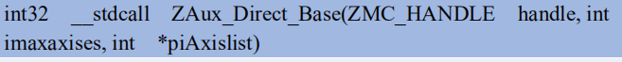

RAPIDSTOP Int32 ZAux_Direct_Rapidstop(IntPtr handle, int imode);

HOMEWAIT Int32 ZAux_Direct_SetHomeWait(IntPtr handle, int iaxis, int fValue);

Datum Int32 ZAux_Direct_Single_Datum(IntPtr handle, int iaxis, int imode);

Idle Int32 ZAux_Direct_GetIfIdle(IntPtr handle, int iaxis, ref int piValue);

Vmove Int32 ZAux_Direct_Single_Vmove(IntPtr handle, int iaxis, int idir);

Cancel Int32 ZAux_Direct_Single_Cancel(IntPtr handle, int iaxis, int imode);

Move Int32 ZAux_Direct_Single_Move(IntPtr handle, int iaxis, float fdistance);

Moveabs Int32 ZAux_Direct_Single_MoveAbs(IntPtr handle, int iaxis, float fdistance);

Dpos Int32 ZAux_Direct_SetDpos(IntPtr handle, int iaxis, float fValue);

Mpos Int32 ZAux_Direct_SetMpos(IntPtr handle, int iaxis, float fValue);

RAPIDSTOP Int32 ZAux_Direct_Rapidstop(IntPtr handle, int imode);

Base

Atype Int32 ZAux_Direct_SetAtype(IntPtr handle, int iaxis, int iValue);

Units Int32 ZAux_Direct_SetUnits(IntPtr handle, int iaxis, float fValue);

Lspeed Int32 ZAux_Direct_SetLspeed(IntPtr handle, int iaxis, float fValue);

Accel Int32 ZAux_Direct_SetAccel(IntPtr handle, int iaxis, float fValue);

Decel Int32 ZAux_Direct_SetDecel(IntPtr handle, int iaxis, float fValue);

Sramp Int32 ZAux_Direct_SetSramp(IntPtr handle, int iaxis, float fValue);

Creep Int32 ZAux_Direct_SetCreep(IntPtr handle, int iaxis, float fValue);

RS_LIMIT



FS_LIMIT



datum_in

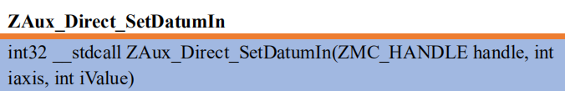

INVERT_IN

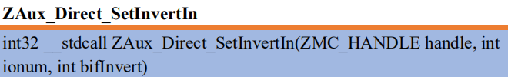

fwd_in

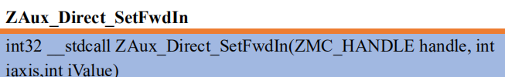

rev_in

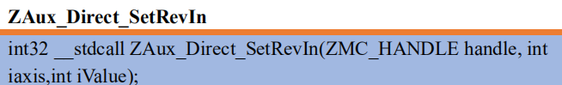

alm_in

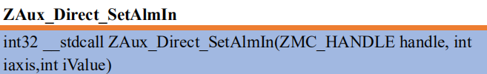

Op Int32 ZAux_Direct_MoveOp(IntPtr handle, int iaxis, int ioutnum, int ivalue);

FLASH_WRITE

u_state

File

DMCPY

ZINDEX_ARRAY

flash_read

move_op2

DMDEL

wa

LOADED Int32 ZAux_Direct_GetLoaded(IntPtr handle, int iaxis, ref int piValue);

Axisstatus Int32 ZAux_Direct_GetAxisStopReason(IntPtr handle, int iaxis, ref int piValue);

read_bit2

STRFIND

DMDEL

force_speed

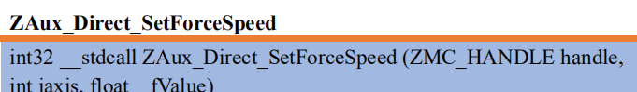

Movesp Int32 ZAux_Direct_MoveSp(IntPtr handle, int imaxaxises, int[] piAxislist, float[] pfDposlist);

Moveabssp Int32 ZAux_Direct_MoveAbsSp(IntPtr handle, int imaxaxises, int[] piAxislist, float[] pfDposlist);

MSPHERICALSP Int32 ZAux_Direct_MSphericalSp(IntPtr handle, int imaxaxises, int[] piAxislist, float fend1, float fend2, float fend3, float fcenter1, float fcenter2, float fcenter3, int imode, float fcenter4, float fcenter5);

ENDMOVE_BUFFER

move_delay



move_op 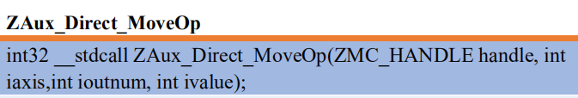

Hmi

ZINDEX_CALL